**Tutorial 02. JavaScript Control Style**

V1.0

25/09/2021

In the previous tutorial, you have learned the basics of JavaScript and used JavaScript to work with HTML element, including

* Retrieve data from HTML element, for example an input
* Manipulate data programmingly
* Update the content of HTML elements

In this tutorial, you will learn how to use JavaScript to control styles. Usually, JavaScript is not used to set CSS rules, rather, it is used to control HTML element classes, which are bonded to predefined CSS rules.

We will start with studying how to use JavaScript to control class list of a HTML element, then following with several examples to learn how to use JavaScript to manipulate style.

Below are the topics of this tutorial.

**Topics**

**1.** **Control HTML element class list with JavaScript** 1

**2.** **Build a multi-select list** 2

**Step 1.** **Create a static style** 2

**Step 2.** **Build a JavaScript function to “toggle” the “selected” class** 3

**Step 3.** **Attach the JavaScript function to each list item** 4

**Step 4.** **Verify the result by click on each item** 5

**Step 5.** **Implement the “Select none” & “Select all” button** 5

**Step 6.** **Verify the final results** 6

**3.** **Build a tabs UI** 6

**4.** **Build a click dropdown** 6

**5.** **Challenge** 7

1. **Control HTML element class list with JavaScript**

Use this tutorial to study the methods defined for “classList”. <https://www.w3schools.com/jsref/prop_element_classlist.asp>

The three methods frequently used are

1. **Build a multi-select list**
   1. **Create a static style**

We always start with building the static look of the UI, like so. In the static page, we randomly “selected” some items by setting the class “selected” to test the design. Later on, the “selected” class will be controlled by JavaScript.

You could copy and paste the codes below and move on the next step

|  |  |
| --- | --- |
| **multi-select-list.html** | **mystyle.css** |
| <!DOCTYPE html>  <html>  <head>  <title>Multi-select List</title>  <link rel="stylesheet" href="./mystyle.css">  </head>  <body>  <h2>Customize Pizza Topping</h2>  <div>  <button type="button">Select none</button>  <button type="button">Select all</button>  </div>    <div class="multi-select-list">  <div class="list-item">Beef Brisket</div>  <div class="list-item selected">Camembert Cheese</div>  <div class="list-item">Indian Butter Sauce</div>  <div class="list-item selected">Seasoned Chicken</div>  <div class="list-item selected">Pineapple</div>  <div class="list-item">Mushroom</div>  <div class="list-item selected">Olives</div>  <div class="list-item">Red Onion</div>  <div class="list-item selected">Tomato</div>  </div>  </body>  </html> | .multi-select-list {  margin: 0;  padding: 0;  width: 200px;  background-color: #f1f1f1;  border: 1px solid #555;  }  .list-item {  color: #000;  padding: 8px 16px;  border-bottom: 1px solid #555;  cursor: pointer;  }  .list-item:last-child {  border-bottom: none;  }  .list-item.selected {  background-color: #04AA6D;  color: white;  }  .list-item:hover:not(.selected) {  background-color: #555;  color: white;  } |

* 1. **Build a JavaScript function to “toggle” the “selected” class**

Create a function with list-item object as parameter, and “toggle” the “selected” class

* If the class list has “selected”, then remove it from the list.
* If the class list doesn’t have “selected”, then add it to the list.

Then link the js file to the HTML file using script tag.

* 1. **Attach the JavaScript function to each list item**

Call the listItemClick function in the onclick attribute of each list item, with “this” variable passed in as parameter.

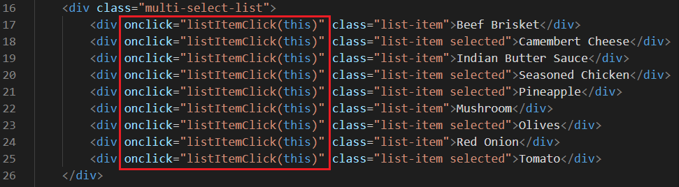

**Note**: in the context above, the “this” variable refers to the element itself, in this case the list item div element. Refer to [this tutorial](https://www.w3schools.com/js/js_this.asp) for more information.

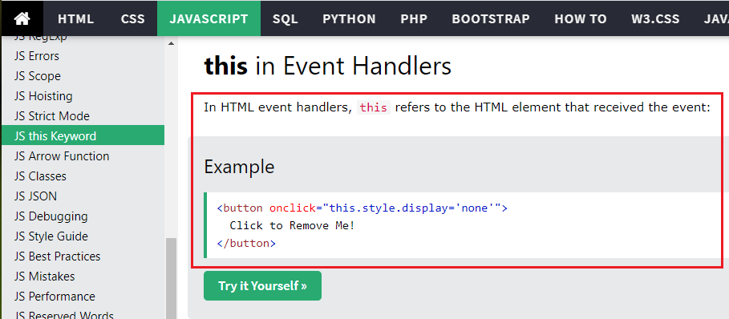

* 1. **Verify the result by click on each item**

Verify if each item can be selected or unselected by clicking on it.

* 1. **Implement the “Select none” & “Select all” button**

The “Select none” and “Select all” functions be implemented this way.

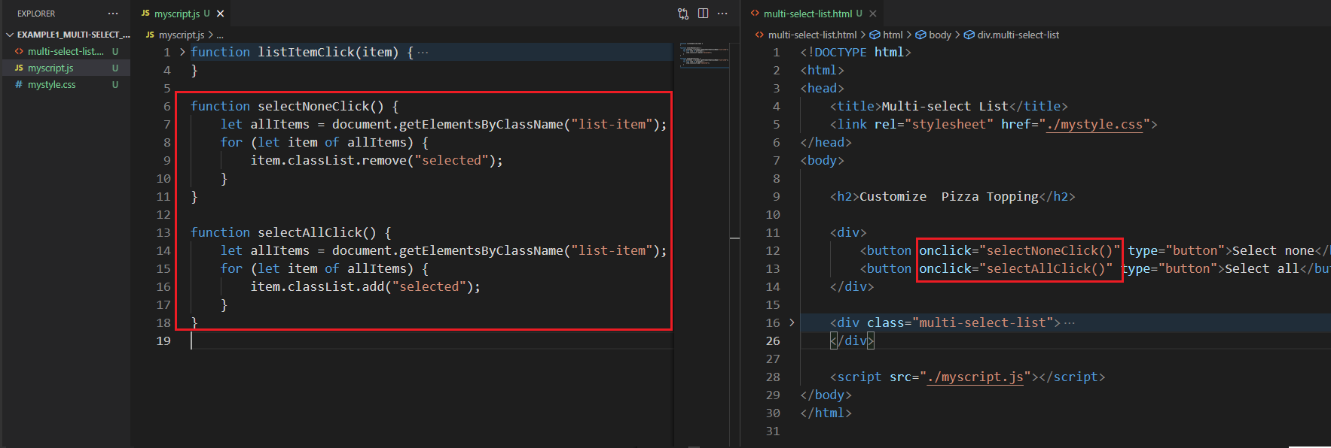

**Note**

* Before, with **document.getElementById()** method, we can get the element object by its id attribute. In the codes above, we used [**document.getElementsByClassName()**](https://www.w3schools.com/jsref/met_document_getelementsbyclassname.asp)method to get a list of element that contain the specific class name.
* With the [for-of](https://www.w3schools.com/js/js_loop_forof.asp) looping structure, we could iterate the element list get above.
  1. **Verify the final results**

You could find the final codes in folder “Example1_Multi-select_List”.

1. **Build a tabs UI**

Study the following tutorials and create tabs UI of different styles.

* Tabs - <https://www.w3schools.com/howto/howto_js_tabs.asp>
* Vertical Tabs - <https://www.w3schools.com/howto/howto_js_vertical_tabs.asp>
* Tab Headers - <https://www.w3schools.com/howto/howto_js_tab_header.asp>

**Note**: in these tutorials, HTML, CSS, JavaScript are coded in one file. I recommend you to separate CSS and JavaScript in separate files.

1. **Build a click dropdown**

Study the following tutorial and create a click dropdown.

* Click dropdown - <https://www.w3schools.com/howto/howto_js_dropdown.asp>

1. **Challenge**

Go to “[How To](https://www.w3schools.com/howto/default.asp)” page on w3schools website and implement some of the UIs by following the examples.

End of this tutorial